NAME:
SECTION:

ITT632 – Mobile Cloud Computing
Lab 1: Mobile Cloud Computing Taxonomy

- Define Cloud computing and explain its key idea.

= Cloud computing is defined as a model that enables ubiquitous, convenient, on-demand network access to a shared pool of configurable computing resources and higher-level services such as networks, servers, storage, applications, and services. These computing resources can be rapidly provisioned and released with minimal management effort or service provider interaction. Moreover, the cloud computing relies on sharing of resources to achieve coherence and economies of scale similar to a public utility.In other word, it allow users to deal with the software without having the hardware where everything could be done by remotely without saving it locally.

- List and explain the five essential characteristics of Cloud Computing.

= The five essential characteristic of Cloud Computing are:

- On-demand self-service

= This characteristic of cloud computing shows that a consumer can unilaterally provision computing capabilities such as server time and network storage as needed automatically without requiring human interaction with each service provider.

- Broad network access

= This characteristic of cloud computing show that it capabilities are available over the network and can be accessed through standard mechanisms that promote use by heterogeneous thin or thick client platforms such as mobile phones, tablets, laptops, and workstations

- Resources pooling

= This characteristic of cloud computing illustrates that the provider’s computing resources are pooled to serve multiple consumers through multi-tenant model, with different physical and virtual resources that can be dynamically assigned and reassigned according to the consumer demand. Therefore, there is a sense of location independence whereby the customer generally possesses neither control nor knowledge regarding the precise location of the provided resources but they may have the capability to specify location at a more abstract level such as country, state, or its data center. The examples of resources include storage, processing, memory, and network bandwidth.

- Rapid elasticity

= This characteristic of cloud computing illustrates its ability elastically provisioned and released, in some cases automatically which then enable rapid scaling both outward and inward that in line with demand. To the consumer, the capabilities available for provisioning often appear to be unlimited and can be obtained in any quantity at any time.

- Measured service

= This characteristic of cloud computing shows that the cloud systems can automatically control and optimize the resource use by leveraging a metering capability at some level of abstraction appropriate to the type of service such as storage, processing, bandwidth, and active user accounts. The resource usage can be monitored, controlled, and reported. These help provide transparency for both the provider and consumer of the utilized service.

- What are the three service models in Cloud Computing? Give one example each.

= 3 service models in cloud computing are:

- Software as a Sevice (SaaS) : Google Workspace
- Platform asa Service (PaaS) : Heroku
- Infrastructure as a Service (IaaS) : Amazon Web Service

- Explain how SaaS benefits mobile users.

= The SaaS model provide numerous benefit to mobile users such as it have a good accessibility, as SaaS application can be access from variety of device as long as there is an internet connection. Thereby, this provide users with the flexibility to work from anywhere and enables team collaboration within organizations in real time. Other benefit for mobile users is that they can always have access to the latest features and security enhancements without the need for manual downloads or install since SaaS model automate the updates. Moreover, its is a cost effective as the charges are based on individual usage and it only need to paid once.

- Describe the difference between Private Cloud and Public Cloud.

= The difference between both of it is that the private cloud describe as the cloud infrastructure that provisioned for exclusive use by a single organization comprising of multiple consumers which it may be owned, managed, and operated by the organization, a third party, or some combination of them, and it may exist on or off premises too. Meanwhile public cloud is describe as the cloud infrastructure that provisioned for open use by the general public which it may be owned, managed, and operated by a business, academic, or government organization, or some combination of them, and it also exists on the premises of the cloud provider.

- What is Mobile Computing and what are its essential characteristics?

= Mobile computing which stand for MC is primarily focus on device mobility and contextual awareness while considering networking and mobile resource/data accessibility. This MC applications typically depend on mobile devices to create, access, process, store, and transmit information without being confined to a singular location. Moreover, MC usually considers similar types of mobile devices that offers many otherwise unattainable benefits to organizations that choose to integrate it into their fixed information system. Its essential characteristic includes portability, miniaturization, connectivity, convergence, divergence, applications, and digital ecosystem.

- Define Mobile Cloud Computing (MCC) and explain how it combines both technologies.

= Mobile cloud computing which also stand for MCC is defined as leverages unified elastic resources of varied clouds and network technologies toward unrestricted functionality, storage, and mobility to serve a multitude of mobile devices anywhere, anytime through the Internet, regardless of heterogeneous environments and platforms based on the pay-as-you use principle. This definition is a combination of cloud computing and mobile computing by describing MCC’s service features focusing on how mobile devices acquire and then use cloud computing based services through mobile networks.

- What is “offloading” in Mobile Cloud Computing? Why is it important?

= “offloading” in Mobile Cloud Computing refers to the process of transferring applications or tasks from mobile device to another device or server that has more power and resources to handle them. This is important because in a mobile cloud, mobile nodes are usually restricted by their energy supply. Therefore mobile devices often have limited battery life and processing capabilities, so this offloading can helps to conserve energy and improve performance. In some cases, if the internet cloud is not available, the consumer can also offload applications to other mobile devices around them in order to share the workload. Each mobile device in this scenario will acts as a surrogate where it helping in distribute the computation tasks and reduce the strain on individual devices. Overall, offloading in Mobile Cloud Computing is a smart way to optimize energy usage and improve performance on mobile devices by shifting the tasks to more capable devices or servers.

- Explain the roles of Clone Cloud in Mobile Cloud Computing.

= The roles of Clone Cloud in Mobile Cloud Computing is a technique that help in energy saving. It works by automatically moving parts of mobile applications to be run in the cloud instead of on the mobile device itself. This helps overcome the limitations of mobile devices such as limited computing power, memory, and energy. Each mobile device is connected to a Clone Cloud, which enhances the capabilities of the device. This can be achieved by dividing an application into different parts that can be executed on a virtual machine, and then some of these parts are offloaded to a mobile clone in the cloud.Therefore, the main idea behind Clone Cloud is that if the cloud can execute tasks better, faster, cheaper, and more securely than the mobile device, then it makes sense to move those tasks to the cloud. Hence, Clone Cloud is allow to decide which parts of the code should be run on the mobile device versus in the cloud, without requiring any changes to the application itself or causing any concerns for the end user.

10. Discuss one real-world example of Mobile Cloud Computing that you personally use.

= For instance, Google Drive serve as an exemplary model as it allows users to store files in the cloud thereby enable the users to access from any device with internet connectivity. This functionality allows users to easily share documents, collaborate with others in real-time, and edit any files simultaneously. This considered beneficial for teams or organizations.

Other example that can illustrate the concept of mobile cloud computing is Cloud gaming services, such as NVIDIA GeForce NOW. These platforms allow gamer to engage in high-quality gaming experience on mobile devices without the need for powerful hardware. By streaming games from the cloud, I can personally enjoy a wide variety of games directly from their smartphones or tablets, regardless of their device's specifications.

- Design a simple mobile application that uses Mobile Cloud Computing (MCC) architecture.

Your app should demonstrate how a mobile device (front-end) connects to a cloud backend (using any cloud model: SaaS, PaaS, or IaaS).

Explain:
- The purpose of your mobile app.
- Which cloud service model does it use (IaaS, PaaS, or SaaS)?
- What data or processing is offloaded to the cloud?
- Include a simple labeled diagram of your app’s architecture.
The mobile application that use Mobile Cloud Computing architecture
= SmartDiet tracker which it is as mobile application that focus on health and nutrition consumption.

The Purpose
= To helps user monitor their daily food and drink intake, diet, calories and receive personalized meal planning recommendations. SmartDiet Tracker will use MCC to store, analyze and process user’s data such as nutrition consumption to the cloud. Hence, this allows users to easily keep track their eating habits and receive personalized diet recommendations across multiple devices.

The app allows users to:

- Record daily intake or meals either manually key in or via photo upload
- Automatically calculate calories and nutrients using a cloud nutrition database
- Obtain AI=generated meal suggestion and insights.
- Sync their data across multiple devices such as phone or tablet.

Cloud Service Model
= It use Platform as a Service (PaaS) because this mobile application will use cloud platform like firebase or google cloud platform to handle data storage, authentication, machine learning recommendation and server-side code. This would help to reduce the need for heavy local computation on the user phone and in fact, it help to reduce the burden of developers to manage the servers manually as they can focus on features rather than managing the server.

Data or processing offloaded to the cloud
=
Offloading | Process | Reason
User Authentication |  | To centralized user management and to increase the security by avoiding the local password storage.
Meal Photo | Once user upload meal photo, the app send image to cloud-based machine learning AP such as Google Vision AI | To reduce the heavy computation on the manual server since machine learning requires high computation power and cloud servers capable as they have GPU/AI processing capabilities.
Nutrional analysis | Once the meal is recognized or manually entered by the user, the data like food name and portion will send to cloud bakcend function | To calculate calorie and nutrition intake

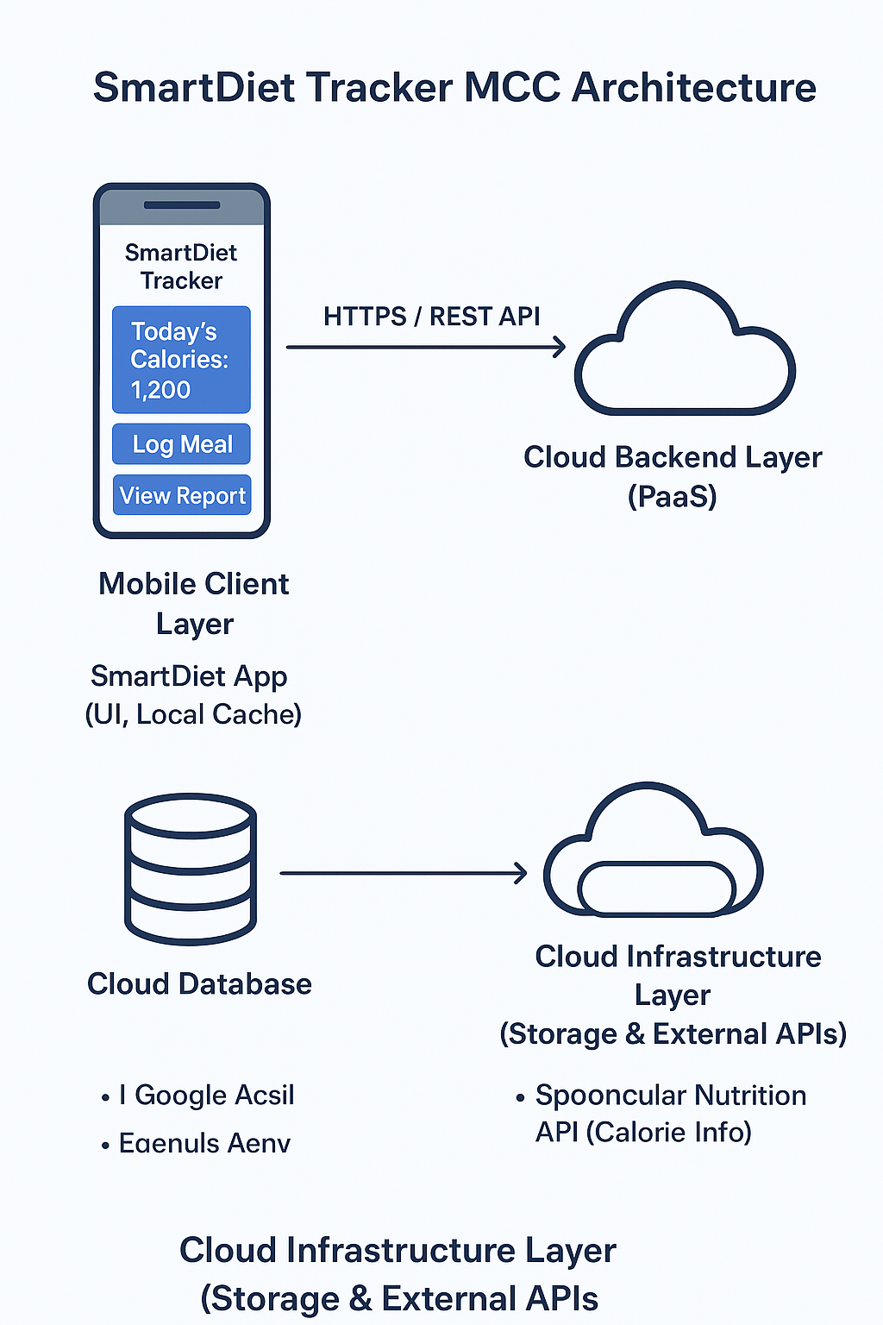

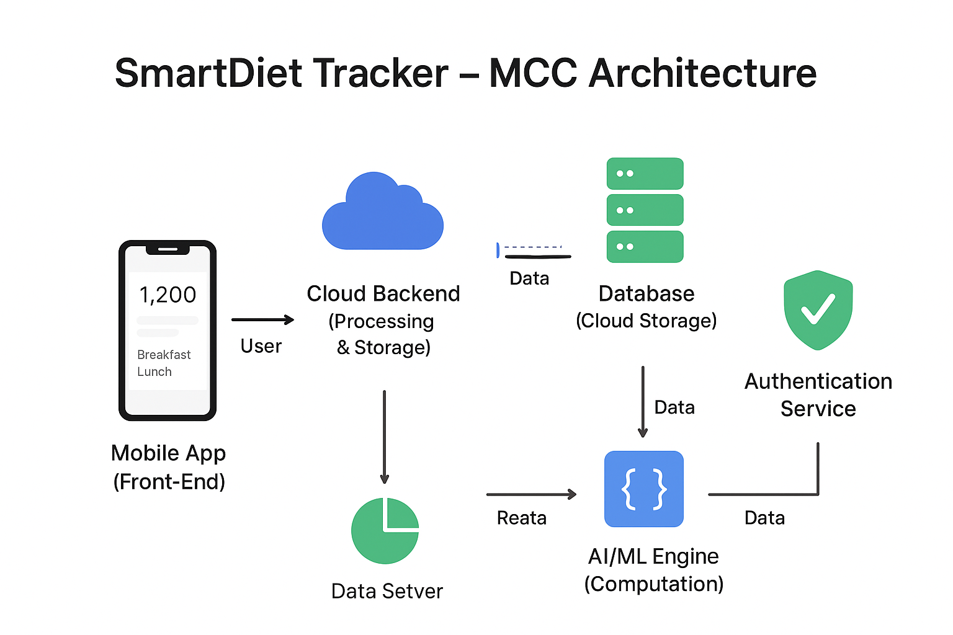

User → Mobile App → Cloud Backend → Database / AI / APIs → Mobile App → User

